Classic Eggs Benedict
Ingredients
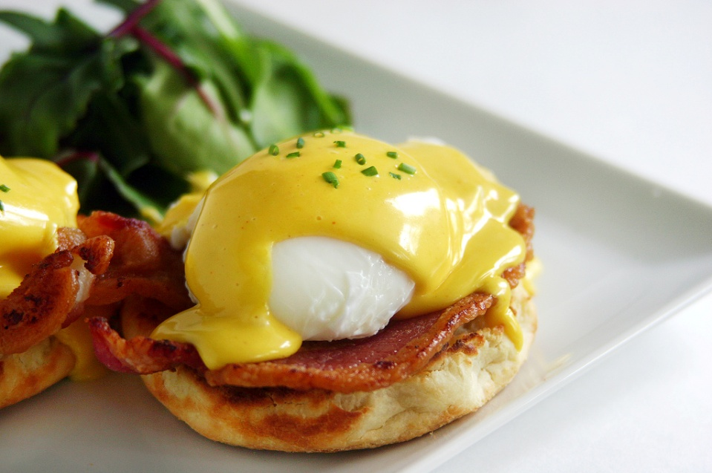
English muffin
500ml milk
50g butter
1pkt yeast
15g granulated sugar
80ml luke warm water
15ml spirit vinegar
5ml fine salt
1 egg whisked
600g plain flour
300g semolina flour

Hollandaise sauce
4 Egg yolks
100ml spirit vinegar
500g butter, melted
2g salt
1g ground white pepper

30 eggs
100ml spirit vinegar
10g salt
200g spinach, cleaned and washed
900g streaky bacon
30g chopped chives
Method
- Place he pizza stone on the fire and allow to get hot
- Place a pot of water on to boil
For the hollandaise
- Place the egg yolks and vinegar into a glass bowl and whisk together over the boiling water until the mixture starts to thicken, slowly start add the melted butter in a contant steady steam, (if the butter is added to fast it will cause the sauce t split and the eggs will cook and turn to scrambled eggs.)
- Once the butter has been added the sauce should be a thick silky sauce that coats the back of a spoon.
For the English muffin
- Place the milk butter in a pot and warm until the butter melts once the butter is melted add the vinegar and egg to the mixture( the mixture will start to curdle this is ok)
- Sprinkle the yeast and sugar over the warm water and stir until the yeast dissolves. Allow the yeast to foam and grow.
- Sift the flour and salt together
- Add the wet ingredients to the flour alternating between the milk mixture and the yeast mixture until all the wet ingredients have been added. The mixture should be a wet dough almost the same consistency as a Ciabatta dough. If the dough is to wet add a little flour to correct the consistency.
- Using a 1/3 cup measure scoop out small amounts of the dough a and drop onto the semolina flour coating the outsides
- Place the a ring mould onto the pizza stone and place the muffin dough inside and allow to cook inside the mould this will make the cook evenly and have a nice round shape
- Cook for 15min on each side or until browned and cooled through and remove from the stone and allow to cool.
- Grill the spinach over the coals to cook through
- Line 8 dariole moulds with cling film and spray with spray and cook making sure that they are completely coated. Place an egg in each dariole mould, fold the plastic up and secure it with a piece of string or a piece of plastic wrap making sure that it seals the egg inside and the egg doesn’t leak out. Place into the boiling water and cook to desired doneness remove from the boiling water and remove the cling film.
- Grill the bacon over the coals so that u get nice char lines and the bacon cooks through ( if u want crispy bacon move to the side of the grill that hasn’t got coals under it else the heat will cause the bacon to burn and taste bitter)
Plating
- Place the English muffin in the center of the plate, top the muffin with the spinach and grilled bacon
- Place the poached egg on top of the bacon and drizzle with the hollandaise and finish with a sprinkling of the chopped chives.

