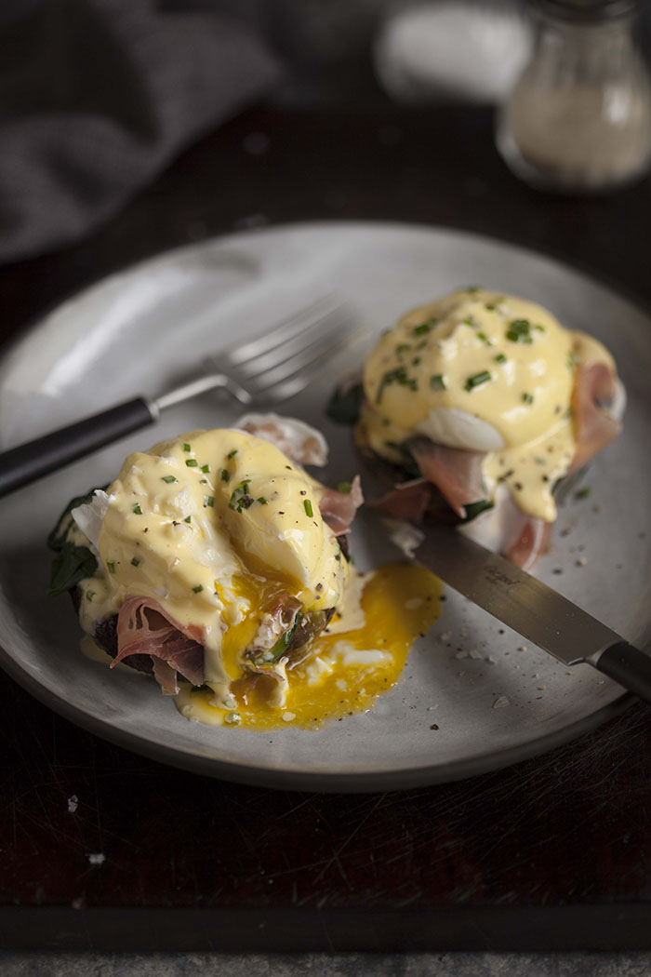
Banting Benedict
Ingredients

500g Large brown mushroom
Hollandaise sauce
2 Egg yolks
50ml spirit vinegar
250g butter, melted
1g salt
1g ground white pepper

15 eggs
50ml spirit vinegar
5g salt
200g spinach, cleaned and washed
100ml Double cream yoghurt
40g Butter
10g Garlic
240g streaky bacon
10g chopped chives
Method
- Place a pot of water on to boil
- Place the egg yolks and vinegar into a glass bowl and whisk together over the boiling water until the mixture starts to thicken, slowly start add the melted butter in a contant steady steam, (if the butter is added to fast it will cause the sauce t split and the eggs will cook and turn to scrambled eggs.)
- Once the butter has been added the sauce should be a thick silky sauce that coats the back of a spoon.
- Line 8 dariole moulds with cling film and spray with spray and cook making sure that they are completely coated. Place an egg in each dariole mould, fold the plastic up and secure it with a piece of string or a piece of plastic wrap making sure that it seals the egg inside and the egg doesn’t leak out. Place into the boiling water and cook to desired doneness remove from the boiling water and remove the cling film.
- Grill the spinach leaves over the coals to cook the spinach and make it soft and easier to roll
- Remove from the grill and roll into sausages and finely shred the grilled spinach
- In a pan heat the dbl cream yoghurt with the garlic and butter add the shredded spinach and reduce down until all the water has been cooked out
- Peal the brown mushrooms and scoop out the gills and the center stork place on the braai hollow side up and grill until soft turning occasionally
- Grill the bacon over the coals so that u get nice char lines and the bacon cooks through ( if u want crispy bacon move to the side of the grill that hasn’t got coals under it else the heat will cause the bacon to burn and taste bitter)
- Plating
- Place the grilled mushroom in the center of the plate, top the mushroom with the creamed spinach and grilled bacon
- Place the poached egg on top of the bacon and drizzle with the hollandaise and finish with a sprinkling of the chopped chives.

